ITRW 212 – 11 May 2017
Assignment 1
Unzip the Java program called SearchSortNames.
The Students text file contains the names of a number of students.
Correct the errors / complete the missing parts in the Data class which contains methods to do the following:
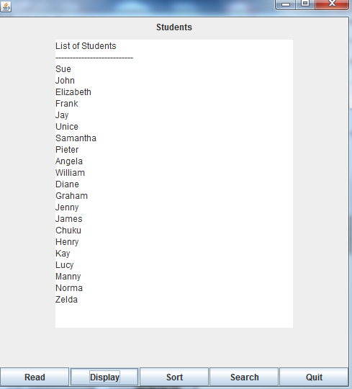
readData:
This is a void method.
The code must read data from the text file into an array called arrStudents.
sortData:
The code must sort the content of an array in alphabetical order. Correct the part that swaps the names.
getCount:
Return the number of elements in the array
getArray:
Return the array

Write code for each button to do the following:
Read:
Call the method to read the names from the text file into an array. Display a suitable message.
Search:
Enter a name to look up. Display a suitable message indicating that the name was found or not found.
Sort:
Call the method to sort the names and display a suitable message.

